

v1.2.0

06-September-2022

USER MANUAL

A10-vThunder_3NIC-3VM

# PATENT PROTECTION

A10 Networks, Inc. products are protected by patents in the U.S. and elsewhere. The following website is provided to satisfy the virtual patent marking provisions of various jurisdictions including the virtual patent marking provisions of the America Invents Act. A10 Networks, Inc. products, including all Thunder Series products, are protected by one or more of U.S. patents and patents pending listed at: a10-virtual-patent-marking.

# TRADEMARKS

A10 Networks, Inc. trademarks are listed at: a10-trademarks.

# CONFIDENTIALITY

This document contains confidential materials proprietary to A10 Networks, Inc. This document and information and ideas herein may not be disclosed, copied, reproduced, or distributed to anyone outside A10 Networks, Inc. without prior written consent of A10 Networks, Inc.

# DISCLAIMER

This document does not create any express or implied warranty about A10 Networks, Inc. or about its products or services, including but not limited to fitness for a particular use and non-infringement. A10 Networks, Inc. has made reasonable efforts to verify that the information contained herein is accurate, but A10 Networks, Inc. assumes no responsibility for its use. All information is provided "as-is." The product specifications and features described in this publication are based on the latest information available; however, specifications are subject to change without notice, and certain features may not be available upon initial product release. Contact A10 Networks, Inc. for current information regarding its products or services. A10 Networks, Inc. products and services are subject to A10 Networks, Inc. standard terms and conditions.

# ENVIRONMENTAL CONSIDERATIONS

Some electronic components may possibly contain dangerous substances. For information on specific component types, please contact the manufacturer of that component. Always consult local authorities for regulations regarding proper disposal of electronic components in your area.

# FURTHER INFORMATION

For additional information about A10 products, terms and conditions of delivery, and pricing, contact your nearest A10 Networks, Inc. location, which can be found by visiting [www.a10networks.com](http://www.a10networks.com/).

Contents

PATENT PROTECTION 1

TRADEMARKS 1

CONFIDENTIALITY 1

DISCLAIMER 1

ENVIRONMENTAL CONSIDERATIONS 1

FURTHER INFORMATION 2

Introduction to Installing vThunder on Microsoft Azure 3

Overview of Microsoft Azure 4

FIGURE 1-1: Launching Cloud Shell 6

FIGURE 1-2: vThunder for Microsoft Azure 6

FIGURE 1-3: GSLB Topology 7

Azure Terminology 7

System Requirements 8

Azure Prerequisites 11

Chapter 1- QuickStart: Install A10 – 3NIC_3VM - Azure portal 11

Overview 11

Install 12

Chapter 2 - Let us Verify. 15

Annexure 17

Annexure 1- Parameters 17

Annexure 2 – Resource list 19

Annexure 3 – Delete servers 23

# Introduction to Installing vThunder on Microsoft Azure

vThunder for Microsoft Azure is a fully operational, software-only version of the ACOS Series Server Load Balancer (SLB), or Application Delivery Controller (ADC) device. It is configurable by ACOS CLI, GUI, AXAPI, and Harmony Controller.

vThunder is a virtual appliance, yet it retains most of the functionality available on the hard- ware based ACOS appliances. Managing vThunder is the same as managing hardware based ACOS device, and vThunder has the same CLI configurations and GUI presentation.

The networking configuration for vThunder is also like hardware based ACOS devices. The maximum throughput of vThunder for Azure is variable and depends on vThunder software license purchase and type instance used to deploy vThunder.

*A10 Networks brings Out-Of-Box template to deploy vThunder along with multiple features and functionality with pre-defined format into azure cloud.*

Please refer below section for more details.

# Overview of Microsoft Azure

With the move to the cloud, many teams have adopted agile development methods. These teams iterate quickly. They need to repeatedly deploy their solutions to the cloud, and know their infrastructure is in a reliable state. As infrastructure has become part of the iterative process, the division between operations and development has disappeared. Teams need to manage infrastructure and application code through a unified process.

To meet these challenges, you can automate deployments and use the practice of infrastructure as code. In code, you define the infrastructure that needs to be deployed. The infrastructure code becomes part of your project. Just like application code, you store the infrastructure code in a source repository and version it. Any one on your team can run the code and deploy similar environments.

To implement infrastructure as code for your Azure solutions, use azure resource manager templates. The template is a json native file that defines the infrastructure and configuration for your project. The template uses declarative syntax, which lets you state what you intend to deploy without having to write the sequence of programming commands to create it. In the template, you specify the resources to deploy and the properties for those resources.

**Microsoft Azure** (formerly known as Windows Azure) is Microsoft’s cloud computing platform. Azure is an industry leader for both infrastructure-as-a-service (IaaS) and platform-as-a-service (PaaS). Azure offers a combination of managed and unmanaged services that lets customers deploy and manage their applications as they see fit.

The Azure cloud computing platform runs on Microsoft data center and is globally dis- tributed across more than a dozen countries. Such global distribution helps ensure customers receive high performance, regardless of where they are located.

Azure is flexible and can support virtually any operating system, from Windows to Linux, any programming language, from Java to C++, and any database, from SQL to Oracle. Azure also offers 99.95% uptime and is the platform that Microsoft uses to run many of its popular ser- vices, such as Bing, Skype, Xbox, and Office 365.

A10 Networks vThunder virtual device can be set up as an instance in Azure’s cloud and can be used to provide a robust global server load balancing (GSLB) service.

Microsoft Azure uses the following tools to create and manage resources:

**Azure Portal** - A web console to create and monitor Azure resources. For more information, refer to <https://azure.microsoft.com/en-in/features/azure-portal/>

**Azure PowerShell** - A set of cmdlets used for managing Azure resources from the command line. Launch Azure PowerShell from a browser within the Azure Cloud Shell or install the software on the system to start a local PowerShell session.

For more information, refer to <https://docs.microsoft.com/en-us/powershell/>

**Azure CLI—** Can also be launched from a browser within the Azure Cloud Shell or install the software on the system to start a local CLI session. For more information, refer to <https://docs.microsoft.com/en-us/cli/azure/overview?view=azure-cli-latest>

You **can** launch Cloud Shell from the top navigation bar of the Azure portal.

## FIGURE 1-1: Launching Cloud Shell



The following figure shows how vThunder fits into the Microsoft Azure infrastructure.

## FIGURE 1-2: vThunder for Microsoft Azure

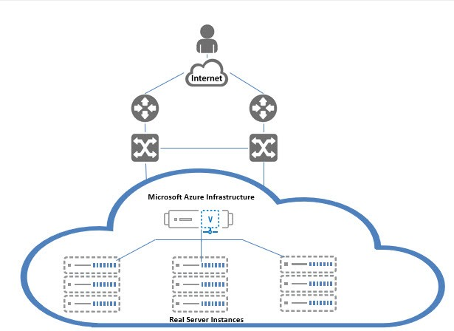

Below diagram shows the topology of 2 regions GSLB. 1 gslb controller and 2 site devices in each region.

## FIGURE 1-3: GSLB Topology

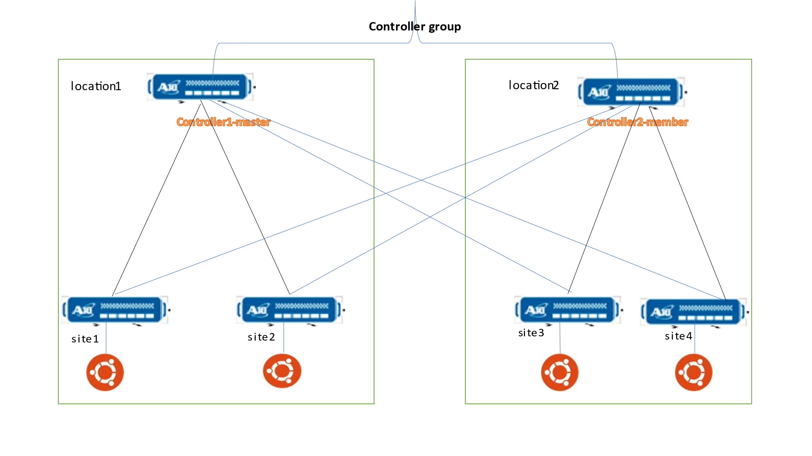

## Azure Terminology

**Azure account** — The Azure account created has different support plans for different regions. For more information on different Azure regions and availability of types of virtual machines in these regions, refer to

<https://docs.microsoft.com/en-us/azure/virtual-machines/linux/overview>

**Resource group** — A resource group is a logical group of all the resources related to an Azure solution. Azure offers flexibility in the allocation of resources to resource groups.

For more information, refer to

[https://docs.microsoft.com/en-us/azure/azure-resource-manager/resource-group- overview](https://docs.microsoft.com/en-us/azure/azure-resource-manager/resource-group-%20overview/)

**Availability set** — An availability set is a logical grouping of Azure VM resources so that each VM resource is isolated from other resources when deployed. This hardware isolation ensures that a minimum number of VMs are impacted during a failure. For more information, refer to

[https://docs.microsoft.com/en-us/azure/azure-resource-manager/resource-group- overview](https://docs.microsoft.com/en-us/azure/azure-resource-manager/resource-group-%20overview/)

**Virtual network** — The Microsoft Azure Virtual Network service enables resources to securely communicate with other resources in an Azure network in the cloud. A virtual network is hence logical isolation of the Azure cloud for an Azure account. You can con- nect different virtual networks and to on-premises networks. For more information, refer to

[https://docs.microsoft.com/en-us/azure/virtual-machines/windows/tutorial-avail- ability-sets](https://docs.microsoft.com/en-us/azure/virtual-machines/windows/tutorial-avail-%20ability-sets/)

**Network security group (NSG)** — A network security group (NSG) contains a list of security rules that allow or deny network traffic to resources connected to Azure virtual networks (VNET). The NSGs can be associated with subnets or individual NICs attached to the VMs. When an NSG is associated with a subnet, the rules apply to all the resources connected to the subnet.

## System Requirements

Below all azure cloud resources will be created.

All templates come with default value it can be change while execution.

1. Azure Resource Group.

New resource group will be created with the specified name and location, in case does not exist.

Default name: *vth-rg1*

1. Virtual Cloud Network. [VCN]

One VNET will be created. VNET name can be configured in parameter file.

Default name: *vth-vnet*

1. Virtual Machine Instance.

**Basic Details:**

**Product: A10 vThunder**

**Instance Name:** *vth-inst1, vth-inst2, vth-inst3*

**Operating system**: Linux

**Default Size**: Standard_B4ms (4 vCPUs, 16 GiB Memory)

Note:

**Highly recommended to do assessment of your projected traffic before selecting any size.

** Instances name and size can be customized in parameter file.

**Supported VM Sizes**

|  |  |  |  |
| --- | --- | --- | --- |
| ***Series*** | ***Size*** | ***Qualified Name*** | ***Accelerated Network*** |
| A series | Standard A4_v2  Standard A4m_v2  Standard/Basic A4  Standard A8_v2 | Standard_A4_v2  Standard_A4m_v2  Standard_A4  Standard_A8_v2 | Not Supported  Not Supported  Not Supported  Not Supported |
| B series | Standard B2_s  Standard B2ms  Standard B4ms | Standard_B2_s  Standard_B2ms  Standard_B4ms | Not Supported  Not Supported  Not Supported |
| D series | Standard D3_v2  Standard DS3_v2  Standard D5_v2 | Standard_D3_v2  Standard_DS3_v2  Standard_D5_v2 | Supported  Supported  Not Supported |
| F series | Standard F4s  Standard F8  Standard F16s | Standard_F4s  Standard_F8  Standard_F16s | Not Supported  Not Supported  Not Supported |

**Note**: ACOS image 6.0.0 and above supports accelerated networking.

Few of sizes are getting retried soon from azure, please refer [Virtual Machine series | Microsoft Azure](https://azure.microsoft.com/en-in/pricing/details/virtual-machines/series/).

For more information, please refer as below.

[Virtual machine sizes for Azure Cloud services (classic) | Microsoft Learn](https://learn.microsoft.com/en-us/azure/cloud-services/cloud-services-sizes-specs)

<https://docs.microsoft.com/en-us/azure/virtual-machines/linux/sizes>.

1. Subnets.

Total three subnets will be created. Subnet name can be configured in parameter file.

Default name:

*subnet_mgmt*

*subnet_data_in*

*subnet_data_out*

1. Public IP’s.

Total 3 Public IP’s will be created for two vThunder’s, IP’s name can be configured in parameter file

*vth-inst1-mgmt-ip*

*vth-inst2-mgmt-ip*

*vth-inst3-mgmt-ip*

1. Secondary Public IP’s.

Total 3 secondary Public IP’s will be created for two vThunder’s, IP’s name can be configured in parameter file

*vth-inst11-dataIn-ip*

*vth-inst21-dataIn-ip*

*vth-inst31-dataIn-ip*

1. Network Security Group. [NSG]

Default all interfaces are associated with security group.

Default name:

*vth-inst1-nsg*

*vth-inst2-nsg*

*vth-inst3-nsg*

1. Network Interface Card. [NIC]

Default name:

*vth-inst1-mgmt-nic*

*vth-inst1-datain-nic*

*vth-inst1-dataout-nic*

*vth-inst2-mgmt-nic*

*vth-inst2-datain-nic*

*vth-inst2-dataout-nic*

*vth-inst3-mgmt-nic*

*vth-inst3-datain-nic*

*vth-inst3-dataout-nic*

Each vThunder consist of two types of NIC.

* Management Interface with public IP
* Data Interfaces with primary private IP. [Ethernet 1, Ethernet 2]

Note: Interfaces holds IP from DHCP.

* Data Interfaces with secondary public IP [vip] and secondary private IP address [fip]

**Server Instances – User will create server instances manually**

2 Linux server instance:

* Default name: vth-server1
* Default name: vth-server2

***Note:***

1. For creating 1 VNET, and 3 subnets, deploy [ARM_TEMPL_VN_SUBNETS_NSG.json](https://a10networks.sharepoint.com/:w:/s/A10CloudNativeTeam/EanQ-4ABcDBJgm1Nx3LHqA4BGRDv6URC79D2Z8vpfJkOVw?e=4NB714)
2. For creating 6 public IP’s , deploy [ARM_TEMPL_VN_SUBNETS_NSG.json](https://a10networks.sharepoint.com/:w:/s/A10CloudNativeTeam/EanQ-4ABcDBJgm1Nx3LHqA4BGRDv6URC79D2Z8vpfJkOVw?e=4NB714) template two times with different parameter values.

## Azure Prerequisites

1. Azure account and valid subscription.

Azure Portal—A web console to create and monitor Azure resources. For more information, refer to <https://azure.microsoft.com/en-in/features/azure-portal/>

# Chapter 1- [QuickStart: Install A10 – 3NIC_3VM - Azure portal](https://learn.microsoft.com/en-us/azure/virtual-network/quick-create-portal)

## Overview

This ARM template will deploy three vThunder instances, one virtual network, three subnets, 6 public IP(s), 12 private IP(s).

Each vThunder will also have three network interfaces attached.

1. Management Interface.
2. Data Interface 1.
3. Data Interface 2.

Thunder creation using this ARM template will be done by using Custom Deployment service of Azure Portal. Default thunder installation and setting will be applied. No SLB configuration will be done.

## Install

1. Click install button displayed on github or download templates from [ARM 1.2.0](https://gitlab.a10networks.com/ax/a10-azure-arm-templates-internal/-/tree/feature/1.2.0_ip_forwarding/ARM-TEMPLATES/A10-vThunder_ADC-3NIC-3VM-2RG-GSLB).

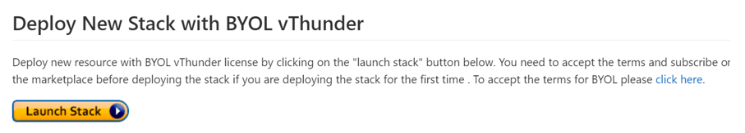

1. Login into Azure Portal.
2. Select Deploy a custom template.

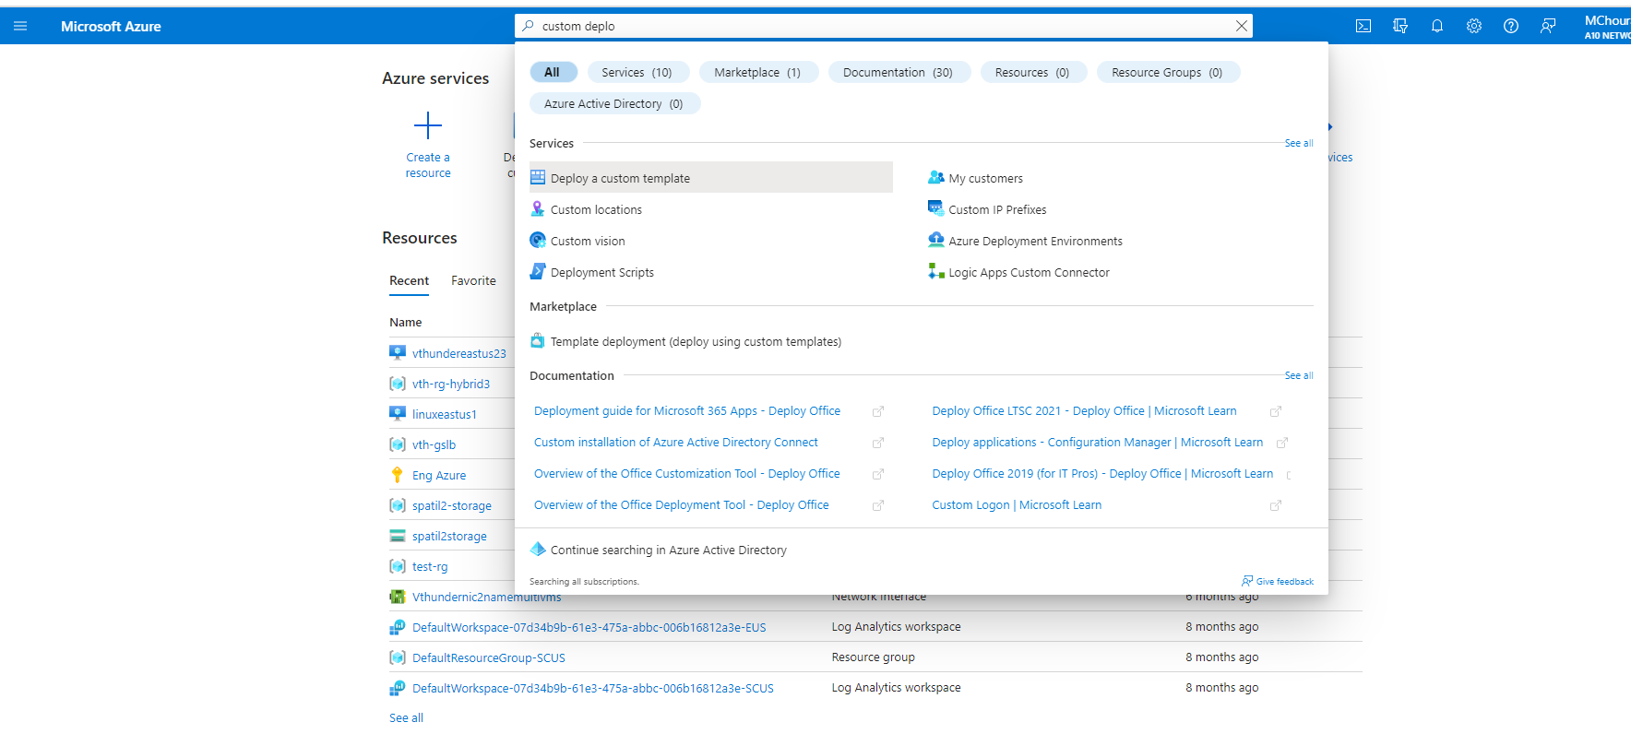

1. Click on “build your own template in the editor”, then user can upload file *A10-vThunder_ADC-3NIC-3VM.json* from local system or paste the content of the file *A10-vThunder_ADC-3NIC-3VM.json* in the editor.

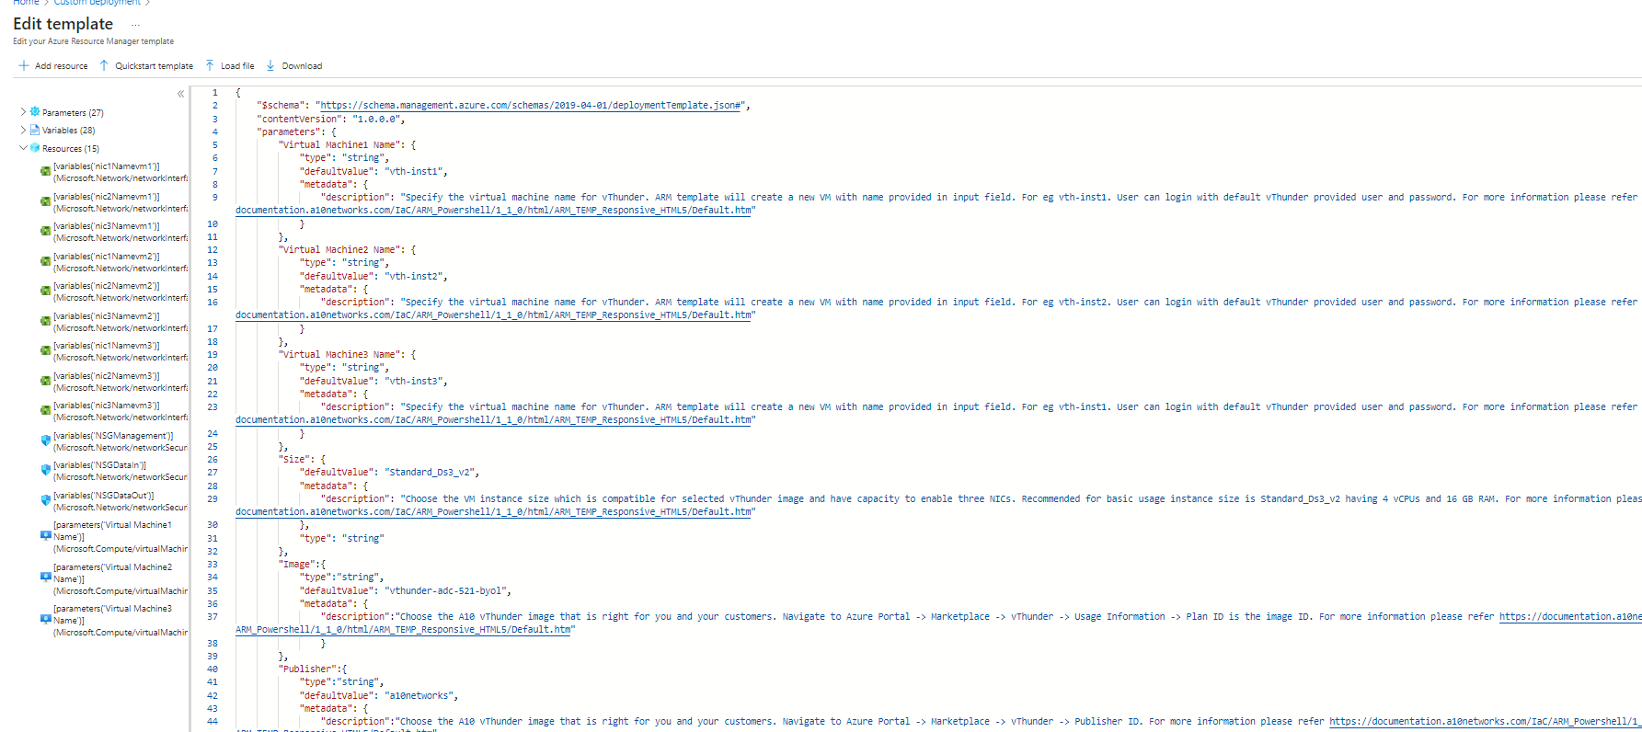

1. Click on *save* button.
2. Fill the empty parameters in the form, update default values if required or keep them as it is.
3. For parameter values refer Annexure 1

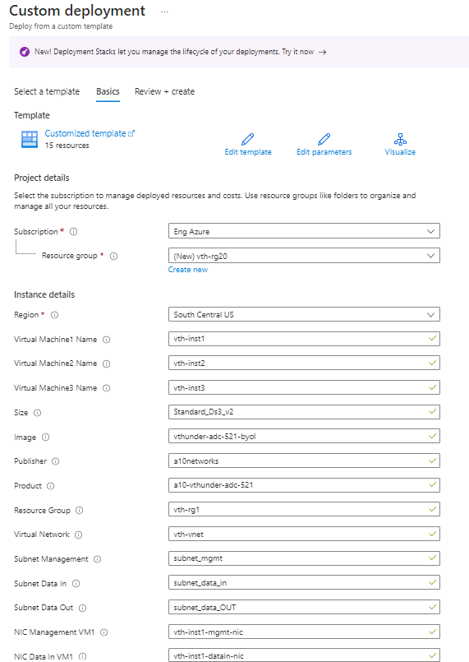­­

1. Click on review and create.



Wait for the validation and the click on create. Set Back and Relax, it will take maximum 10 mins.

**Notes:**

1. User can use existing Virtual network, Network security group, Subnets, and public IP’s.
2. Below listed sizes are verified for vThunder.

|  |  |  |  |
| --- | --- | --- | --- |
| ***Series*** | ***Size*** | ***Qualified Name*** | ***Accelerated Network Supported*** |
| A series | Standard A4_v2  Standard A4m_v2  Standard/Basic A4  Standard A8_v2 | Standard_A4_v2  Standard_A4m_v2  Standard_A4  Standard_A8_v2 | Not Supported  Not Supported  Not Supported  Not Supported |
| B series | Standard B2_s  Standard B2ms  Standard B4ms | Standard_B2_s  Standard_B2ms  Standard_B4ms | Not Supported  Not Supported  Not Supported |
| D series | Standard D3_v2  Standard DS3_v2  Standard D5_v2 | Standard_D3_v2  Standard_DS3_v2  Standard_D5_v2 | Supported  Supported  Not Supported |
| F series | Standard F4s  Standard F8  Standard F16s | Standard_F4s  Standard_F8  Standard_F16s | Not Supported  Not Supported  Not Supported |

Few of sizes are getting retired soon from azure, please refer [Virtual Machine series | Microsoft Azure](https://azure.microsoft.com/en-in/pricing/details/virtual-machines/series/).

For more information, please refer as below.

[Virtual machine sizes for Azure Cloud services (classic) | Microsoft Learn](https://learn.microsoft.com/en-us/azure/cloud-services/cloud-services-sizes-specs)

<https://docs.microsoft.com/en-us/azure/virtual-machines/linux/sizes>.

# Chapter 2 - Let us Verify.

All the resources are created.

1. 3 vThunder should get created



1. 3 network security group should get created



1. Management and data interface should get created for each vThunder

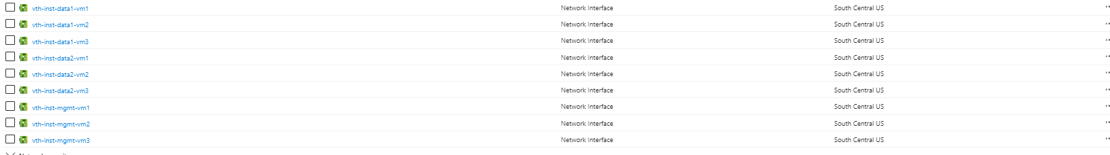

1. Public IP’s should get created for each vThunder from [ARM_TEMPL_VN_SUBNETS_NSG.json](https://a10networks.sharepoint.com/:w:/s/A10CloudNativeTeam/EanQ-4ABcDBJgm1Nx3LHqA4BGRDv6URC79D2Z8vpfJkOVw?e=4NB714)

1. A virtual private network should get created from [ARM_TEMPL_VN_SUBNETS_NSG.json](https://a10networks.sharepoint.com/:w:/s/A10CloudNativeTeam/EanQ-4ABcDBJgm1Nx3LHqA4BGRDv6URC79D2Z8vpfJkOVw?e=4NB714)

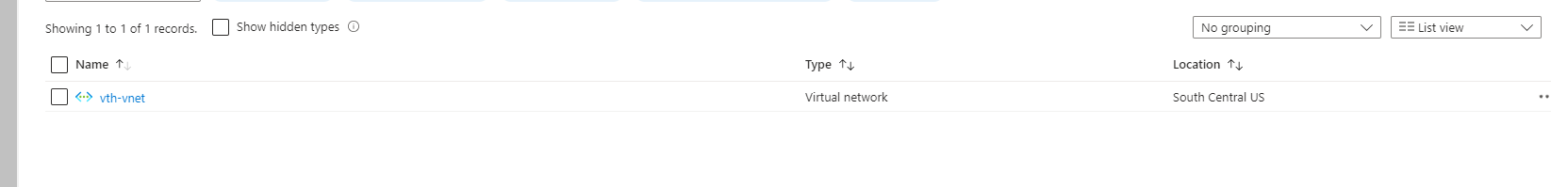

1. GUI – Login and Verify
2. ­Go to azure home page -> *search resource groups-> resource group name*
3. Verify all above resources created.
4. Verify status check of vThunder instance we created.
5. Open any browser and type http://<vThunder_public_IP>
6. Enter username – admin
7. Enter Password – a10(default)

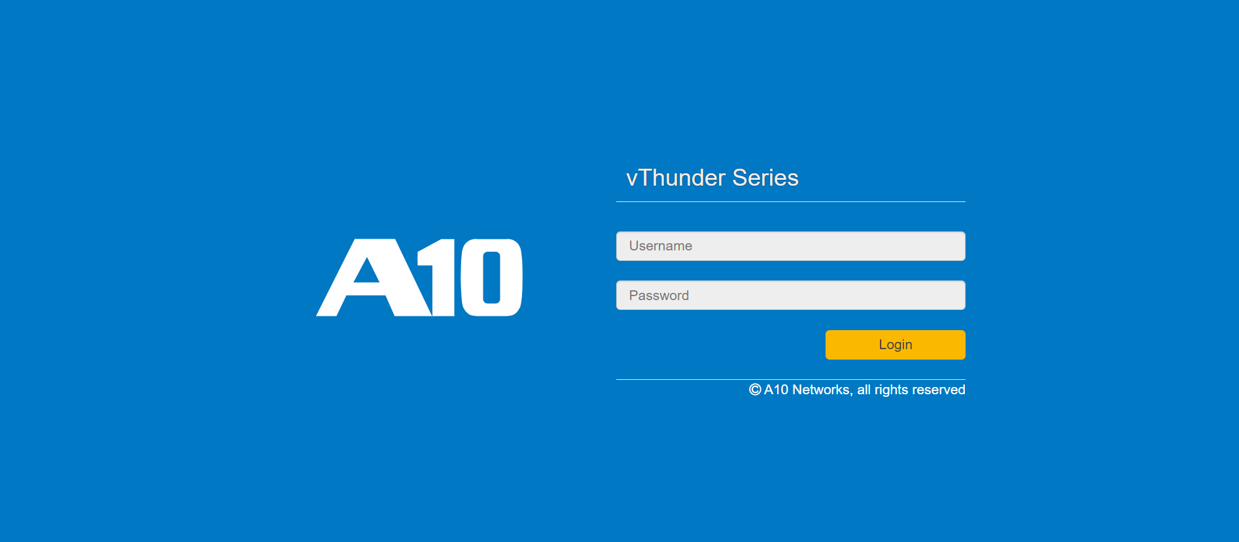

# Annexure

## Annexure 1- Parameters

1. Virtual Network

Description: CIDR subnet for vpn

Default name: vth-vnet

1. ResourceGroup

Description: VNET, subnet public IP’s Resource group Name

Default name: vth-rg1

1. Subnet Management

Description: CIDR subnet for management interface.

Default name: subnet_mgmt

1. Subnet Data In

Description: CIDR subnet for data-in interface.

Default name: subnet_data_in

1. Subnet Data Out

Description: CIDR subnet for data-out interface.

Default name: subnet_data_out

1. NIC Management VM1

Description: Management nic name of vThunder 1.

Default name: vth-inst1-mgmt-nic

1. NIC DataIn VM1

Description: DataIn nic name of vThunder 1.

Default name: vth-inst1-datain-nic

1. NIC DataOut VM1

Description: DataOut nic name of vThunder1.

Default name: vth-inst1-dataout-nic

1. NIC Management VM2

Description: Management nic name of vThunder 2.

Default name: vth-inst2-mgmt-nic

1. NIC DataIn VM2

Description: DataIn nic name of vThunder 2.

Default name: vth-inst2-datain-nic

1. NIC DataOut VM2

Description: DataOut nic name of vThunder 2.

Default name: vth-inst2-dataout-nic

1. NIC Management VM3

Description: Management nic name of vThunder 3.

Default name: vth-inst3-mgmt-nic

1. NIC DataIn VM3

Description: DataIn nic name of vThunder 3.

Default name: vth-inst3-datain-nic

1. Public IP Name VM1

Description: Public IP name of vThunder1.

Default name: vth-inst1-mgmt-ip

1. Secondary Public IP Name VM1

Description: DataIn interface secondary public IP of vThunder1

Default name: vth-inst11-dataIn-ip

1. Public IP Name VM2

Description: Public IP name of vThunder2.

Default name: vth-inst2-mgmt-ip

1. Secondary Public IP Name VM2

Description: DataIn interface secondary public IP of vThunder2.

Default name: vth-inst2-dataIn-ip

1. Public IP Name VM3

Description: Public IP name of vThunder3.

Default name: vth-inst3-mgmt-ip

1. Secondary Public IP Name VM3

Description: DataIn interface secondary public IP of vThunder3

Default name: vth-inst3-dataIn-ip

## Annexure 2 – Resource list

User need find the information about the vThunder instances public IP, private IP and secondary IP’s

Path: resourceGroup->vThunder-name->networking->interface-name->primary/secondary IP

vth-inst1

1. Public IP address of management interface

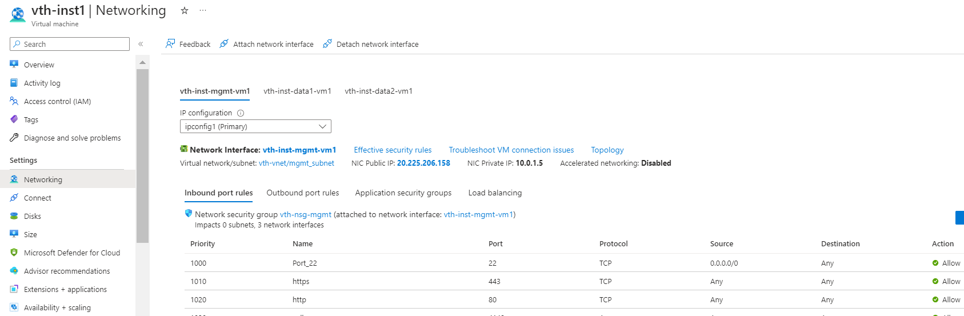

1. Secondary private IP of data1 interface

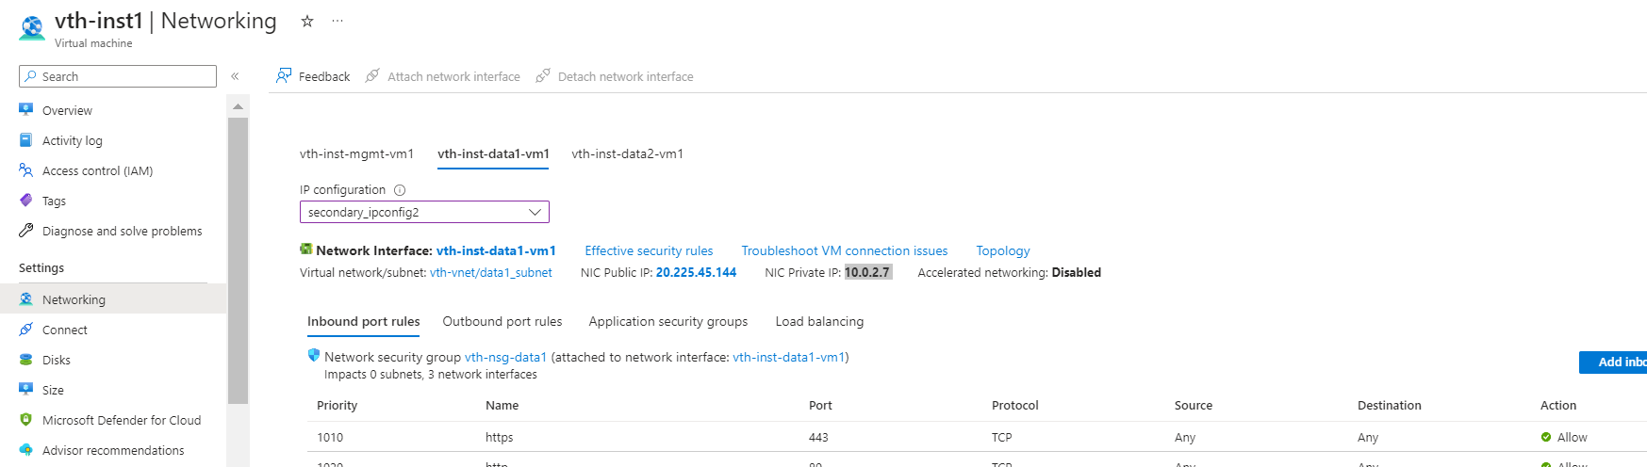

1. Secondary public IP of data1 interface

vth-inst2

1. Public IP of management interface

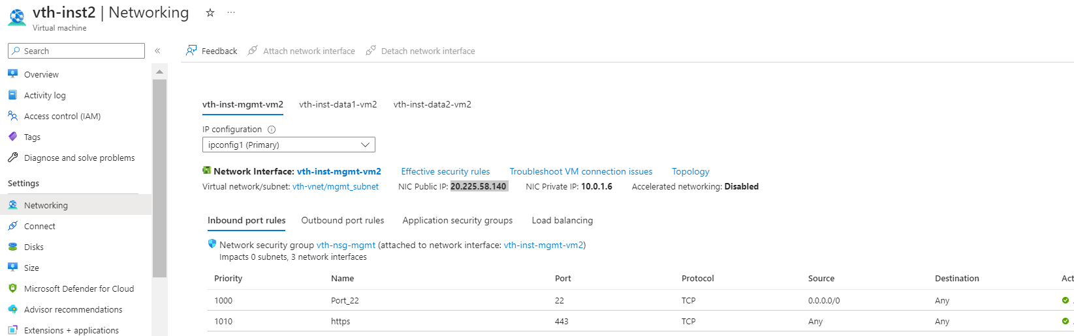

1. Secondary private IP of data1 interface

1. Secondary public IP of data1 interface

vth-inst3

1. Public IP of management interface

1. Secondary private IP of data1 interface

1. Secondary public IP of data1 interface

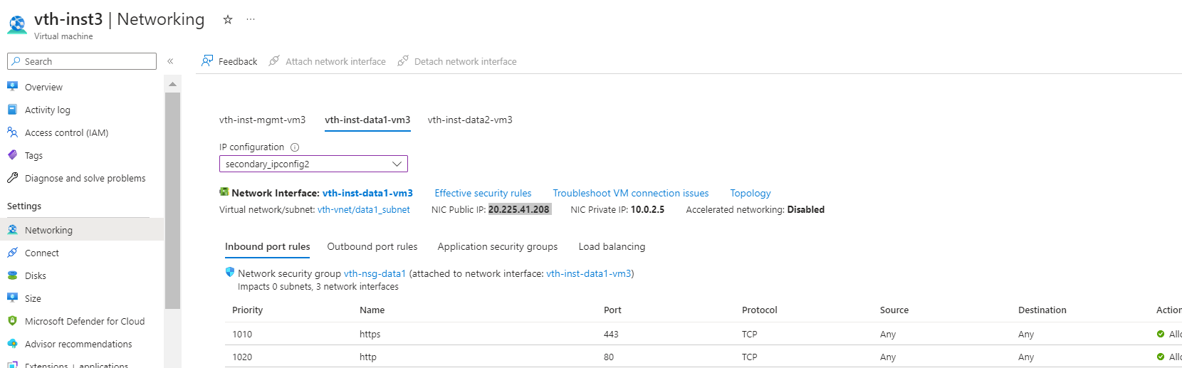

vth-server1

1. Public IP of management interface of server 1 machine.

vth-server2

1. Public IP of management interface of server 2 machine

## Annexure 3 – Delete servers

Once you are done with testing your traffic, you can delete the servers created by ARM template.

1. Navigate to the Resource Group -> <Your Virtual Machine> -> Overview.
2. Click on stop/delete.